British Liver Trust and UK Liver Alliance
Annual update for BSG

The British Liver Trust provides the secretariat for the UK Liver Alliance. This year this has included designing, writing and hosting the new website and writing several joint letters to Ministers and senior civil servants. The Trust also support the UK Liver Alliance with key public affairs and policy work over the last year. This report provides highlights of some of that work.

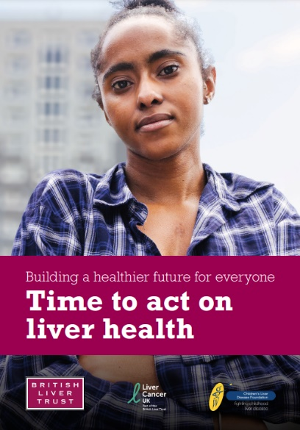
Following the announcement of the General Election on 22nd May we entered a pre-election period of ‘heightened sensitivity’. We shared our manifesto with Prospective Parliamentary Candidates (PPCs) during this period, we received responses from 80 PPCs and over 1,000 opened the manifesto.

Following the election we launched our policy report ‘Time to Act on Liver Health’. The report captured a more visual approach to our public affairs collateral and provides a fresh look and feel to communicate our work and the patients we represent, following our merger with the Children’s Liver Disease Foundation.

The report seeks to challenge stigma, prejudice and misconceptions around liver disease and liver cancer – everyone can be affected by liver disease. 134 MPs were contacted by our supporters sharing the report and requesting they meet with us.

Transformation status and progress in Scotland
Following sustained campaigning by the British Liver Trust on behalf of patients we are delighted that liver disease has been made a major NHS priority. The Trust worked with the Clinical Reference Group responsible for commissioning liver disease to make the case for change and we are delighted that adult liver disease has now been awarded ‘transformative status’. The project included gathering data and evidence and an initial equality health impact assessment. We provided insight from patients gathered from our helpline and patient surveys. 5 key primary drivers have been identified including awareness, prevention, detection, treatment, and integration. The work will commence in Autumn 2025.

We have also been campaigning and progressing our work in Scotland with ministerial meetings, debates, roadshows and ongoing cross-party advocacy. This has included meetings with Cabinet Secretary for Health, Neil Gray and the Labour Health Minister, Jackie Baillie. We are delighted that the Cabinet Secretary for Health, Neil Gray has confirmed that the Scottish Gov will be prioritising Early Detection of liver disease and that the Specialty Delivery Group has met to progress this work.

APPG on Liver Disease and Liver Cancer
We launched the post-election All-Party Parliamentary Group on Liver Disease and Liver Cancer in February 2025. Dr Beccy Cooper MP (Labour) and Lorraine Beavers MP (Labour) co-chair the Group, with Robin Swann MP (UUP) and Peter Bedford MP (Conservative) acting as Vice-Chairs.

The new group will drive policy change for liver disease and liver cancer patients across the UK. Key policy areas include prevention, early diagnosis, and tackling health inequalities.

We will campaign on the impact of social and commercial determinants of health on liver disease mortality rates and hospitalisations –
representing some of the UK’s most deprived and marginalised communities.
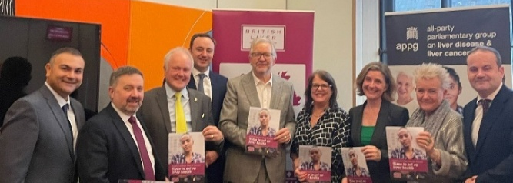
Other attendees at the launch (pictured left) included Danny Chambers MP (Liberal Democrat, Winchester), Peter Dowd MP (Labour, Bootle), Douglas McAllister MP (Labour, West Dunbartonshire), and Clive Jones (Liberal Democrat, Wokingham).

Love Your Liver Westminster Parliamentary Awareness Day
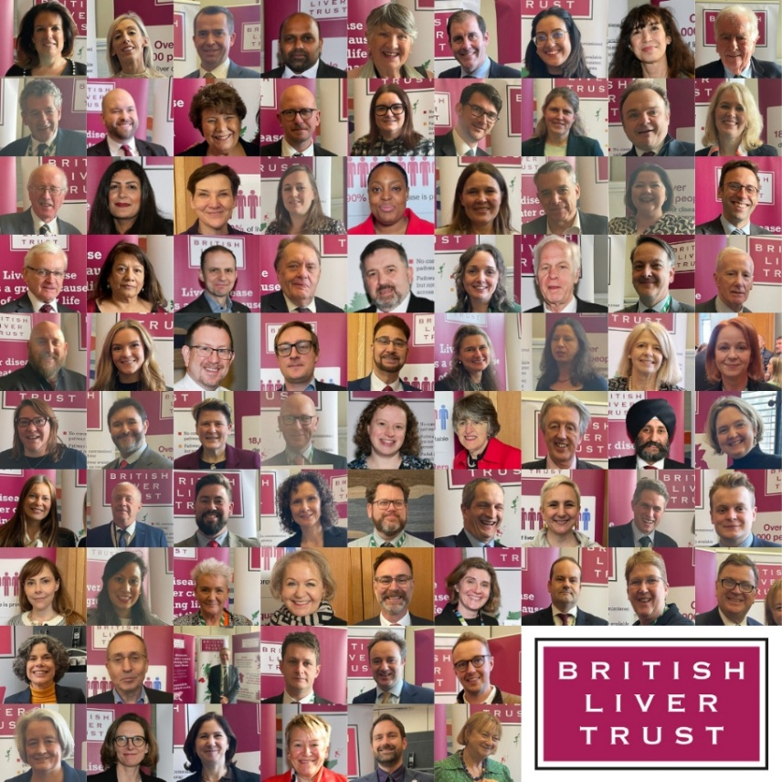
We held our annual Parliamentary Love Your Liver Day event in Westminster in January 2025, which was attended by a record 90 MPs and Peers, including Andrew Gwynne MP, the then Parliamentary Under-Secretary of State for Public Health and Prevention and Dr Beccy Cooper MP, the event’s lead sponsor.

We were also joined by four inspiring patient advocates and a number of clinicians.

We engaged with MPs and Peers to highlight the liver health crisis and the critical role of prevention and early detection of liver disease in improving outcomes. During the event, we provided free non-invasive liver scans to 103 attendees, demonstrating the effectiveness of early diagnostic tools in community settings.

Hepatitis B: Break the Silence
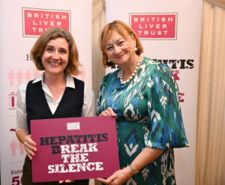
We launched our policy report Hepatitis B – Break the Silence in December 2025 in Parliament. We were joined by politicians, clinicians and policy makers. The launch called on government to make progress on hepatitis B so the UK can meet the World Health Organization’s goals to eliminate hepatitis by 2030.

The report outlines key areas to be addressed, to meet the 2030 goals which include: appointing a national clinical lead to ensure that progress in hepatitis B diagnosis and management structures appropriately replicate hepatitis C elimination (which is on track to meet the elimination deadline), better early detection, access to treatment, peer support, improving data sharing across NHS digital systems and a public health campaign.
Pamela Healy with Co-Chair of the APPG on Liver Disease and Liver Cancer, Dr Beccy Cooper MP

Since April 2022, opt-out testing has diagnosed more than 10,000 people with a blood-borne virus – 5,000 were hepatitis B. We held a roundtable on opt-out testing in partnership with the Terrence Higgins Trust, National Aids Trust, Elton John Foundation and Hepatitis C Trust in April 2025 to call for the current programme (NIHR phase 2 & 3) to be funded in full. The meeting was sponsored by Kevin McKenna MP.

Following a letter from the UK Liver Alliance, we have held a series of meetings with Professor Sir Stephen Powis, National Medical Director, and Professor James D Palmer, National Medical Director for Specialised Services, to discuss the World Health Organisation’s 2030 elimination targets on hepatitis B. As a result Mark Gillyon-Powell is now a national clinical lead – one of our key recommendations for change. The Trust wrote and placed an Opinion Piece for Beccy Cooper MP and the recent NHSE blog highlights some of the work going forward.

Political outreach meetings
Pamela Healy and our Trustee Professor Doug Thorburn have met with Wes Streeting MP on several occasions as part of the consultation on the 10 Year Health Plan and in private meetings. Since launching our #TimeToAct on liver health campaign, 202 supporters have written to 174 MPs. We have also held outreach meetings with a many target MPs including: Edward Argar MP (Conservative, Shadow Secretary of State for Health), Dr Beccy Cooper MP (Labour), Dr Caroline Johnson MP (Conservative Health Team), Liz Twist MP (Labour), Danny Chambers MP (Liberal Democrat Health Team), Rebecca Smith MP (Conservative), Deirdre Costigan MP (Labour), Caroline Nokes MP (Conservative), Vicki Slade MP (Liberal Democrat), Cabinet Secretary for Health (Scotland) Neil Gray MSP (SNP), Martin Vickers MP (Conservative), Michael Wheeler MP (Labour), Afzal Khan MP (Labour), Lorraine Beavers MP (Labour), Ellie Reeves MP (Labour) and Paulette Hamilton MP(Labour), Kevin McKenna MP (Labour), Tim Roca MP (Labour), Jackie Baillie MSP, Deputy Leader of the Scottish Labour Party and Shadow Cabinet Secretary for NHS Recovery, Health and Social Care and Drugs Policy, and Elena Whitham (former MUP minister SNP) and Sarah Russell MP (Labour).

These meeting were attended by our CEO, Director of Communications and Policy, and the policy team.
Love Your Liver roadshows & Hospital Liver Unit visits
The Love Your Liver roadshow visited the Scottish Parliament in May 2024. We were joined by 20 MSPs including the Cabinet Secretary for Health, Neil Gray MSP, Minister for Public Health, Jenni Minto MSP and Minister for Drug and Alcohol Policy, Christina McKelvie MSP. Dr Mathis Heydtmann, specialty adviser to the Scottish Chief Medical Officer (liver), and Anja Adair, Consultant Transplant & Hepatobiliary Surgeon at Edinburgh Royal Infirmary, and the British Liver Trust’s Chair of Trustees Alastair King.

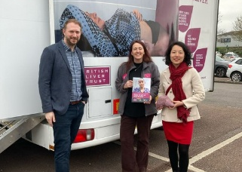
Our CEO Pamela Healy OBE officially opened the new state-of-the-art Liver Unit at University Hospitals Plymouth NHS Trust. In attendance was Rebecca Smith MP, the newly elected MP for South West Devon, Professor Matthew Cramp and several patients who have been treated at the hospital were there to share their experiences.

Yuan Yang MP attended our Love Your Liver Roadshow in Reading in March (pictured right).
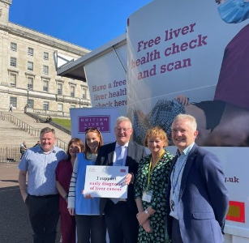
We held our first ever Love Your Liver roadshow at the Northern Ireland Assembly in September 2024 (pictured left).

We were joined by 45 MLAs, including Mike Nesbitt MLA, Minister for Health and the Chair and Deputy Chair of the Health and Social Care Committee, Liz Kimmins MLA and Danny Donnelly MLA. We were also joined by the Deputy First Minister Emma Little-Pengelly MLA and the Attorney General for Northern Ireland, Dame Brenda King. On the day we scanned 133 people, including MLAs, Assembly staff and members of the public. The event was sponsored by Nuala McAllister MLA.

Parliamentary debates
We held our last Westminster Hall Debate in the 2019 – 2024 parliamentary session on “health inequalities in liver disease and liver cancer” in April 2024. The debate picked up on a sector trend to highlight inequalities and the social and commercial determinates of health, and highlighted how liver disease disproportionately impacts communities in the north of England, Wales, Scotland and Northern Ireland - a theme which we have progressed in the current parliament to leverage on the shift in political gravity to the north of England and devolved nations. The House of Commons library debate pack extensively referenced the British Liver Trust and borrowed from our debate briefing, strengthening our policy footprint CDP-2024-0070.pdf (parliament.uk).

In October 2024 we arranged a debate in the Scottish Parliament – Member’s Business Debate on raising awareness of liver disease, to coincide with Liver Cancer Awareness Month. The Convenor of the Health, Social Care and Sports Committee, Clare Haughey MSP, sponsored our motion, which was backed by over 30 cross party MSPs. Speakers included Jackie Bailie MSP, Scottish Labour Party Spokesperson on Health and Gillian Mackay MSP, Scottish Green Party Spokesperson on Health and Social Care and Public Health Minister, Jenni Minto MSP. Key themes included, prevention, early detection and tackling health inequalities, with a particular focus on the impact of Minimum Unit Pricing on alcohol, the need for early detection pathways for liver disease across all Health Boards and the nationwide rollout of the SCOT HPB pathway for liver cancer. We met with third party sector stakeholders, including Alcohol Focus Scotland to align on messaging around tackling alcohol harm.

The Co-Chair of the APPG on Liver Disease and Liver Cancer Dr Beccy Cooper MP, has also secured a debate via the Backbench Business Committee on obesity and MASLD. Subject to parliamentary and DH ministerial availability this should go ahead in September 2025.

British Journal of GPs (BJGP) cross-sectional survey on liver disease management
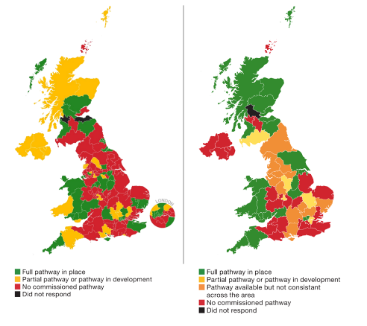
The BJGP Open published our cross-sectional survey on increasing engagement with liver disease management across the UK, which underpins the ‘make early diagnosis of liver disease routine’ campaign in January 2025. The study, based on our 2023 resurvey of all Integrated Care Systems and Health Boards, was co-produced with Dr Helen Jarvis and Professor Stephen Ryder. Media release:

New research reveals 80% of England does not have an effective pathway for the early detection of liver disease despite huge rises in deaths. - British Liver Trust

The study maps early detection pathways and the level of engagement with community chronic liver disease management among ICSs and health authorities. A cross-sectional follow-up survey to ICS and UK health boards mirroring our previous survey in 2020 was sent to all regional health bodies. We will continue to use this data to drive improvements across the UK.

Policy review
Over the last year, the new Labour Government have brought forward significant changes and restructuring to health policy in England. The Darzi Review found the NHS is in a “critical” condition – public trust is at its lowest, and patients are enduring long waits across all services.

The Government’s 10 Year Health Plan was published in July 2025, which sets out how to deliver on three major shifts: from hospital to community, from analogue to digital, and from sickness to prevention. The British Liver Trust contributed to the consultation process, working with a range of patient and clinical groups to develop comprehensive, co-created submissions. This ensured that the views of people affected by liver disease and liver cancer and clinicians were communicated to ministers and officials involved in drafting the plan. Our response: British Liver Trust response to the 10-Year Health Plan - British Liver Trust.
We have campaigned in partnership with the third sector to back a Private Members’ Bill on Rare Cancers (sponsor Dr Scott Arthur) The Rare Cancers Bill: A Step Forward for Liver Cancer Patients - British Liver Trust.

The APPG on Less Survivable Cancers published their mini report into less survivable cancers in June: Early diagnosis of less survivable cancers could save 7,500 lives annually - Less Survivable Cancers Taskforce. Trustee, Prof. Stephen Ryder, attended the inquiry’s roundtable on diagnosing less survivable cancers at an early stage and explored potential solutions to improve survival rates.

We submitted responses to consultations, including the Cancer Plan expected to be published in July, Change NHS, MUP Wales and the Men’s Health Strategy. We also fed into the Health and Social Care Committee’s call for proposals for future inquiries through a joint submission for the Less Survivable Cancer Taskforce. We have written to DH ministers on a range of issues and the Health Committee Chair Layla Moran MP asking for the HSCC committee to ensure liver disease and liver cancer feature in its future programme of work. We had a number of meetings with Tim Jones, Director of Cancer at the Department of Health and Social Care, on the Cancer Plan. We have also met with the Cabinet Secretary for Health (Scotland), Neil Gray MSP, and his team, to discuss a range of issues including the future of the Scot HPB pathway for liver cancer.

We also submitted evidence on behalf of patients to the NICE Single Technology Appraisal on Durvalumab with tremelimumab for untreated advanced or unresectable hepatocellular carcinoma, and provided exemplar pathways and data from our patient survey to inform NHSE’s MASLD pathway development.

British Liver Trust mobile unit visit to BSG LIVE 2025 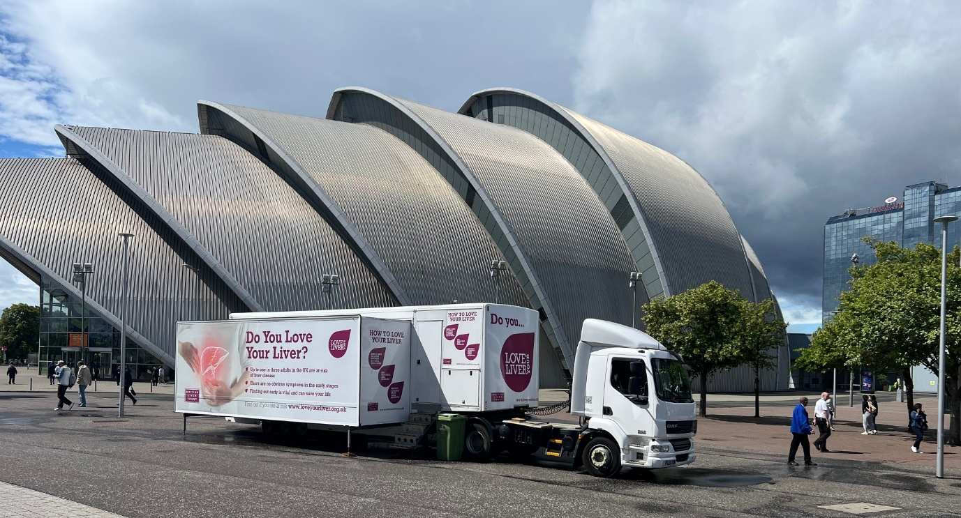

The British Liver Trust mobile unit made its debut visit to BSG LIVE this year (pictured above), enabling our team to meet delegates at the event and hear more about how we can support as many healthcare professionals and their patients as possible.

We know that for many liver patients, their first encounter with a healthcare professional in a hospital setting is within gastroenterology teams. The profile of the Trust with hepatology specialist teams is generally strong, but we were keen to maximise the opportunity to let gastroenterology teams know about our resources, information and support services so that patients can benefit.

Taking the mobile unit to BSG LIVE was a fantastic chance for us to do this, and it also offered the opportunity to meet with primary care delegates, hepatology teams and a wide range of industry partners. We know how important it is for patients, their families and carers to have access to high quality, reputable information and support. By working together with healthcare professionals and supporting the amazing care they provide daily, we can help to provide anyone affected by liver disease or liver cancer as much help and information as possible.

The mobile unit was located outside the entrance to the exhibition building, making it easy for delegates to drop in and meet us. During their visit, they were able to:

- Meet the British Liver Trust team, including CEO Pamela Healy to hear more about the work of the Trust and partnership working opportunities
- Tour the mobile unit and review the liver health screener used to promote awareness and provide advice to the public
- Look at sample materials and resources available for distribution to patients, as well as the information bank available online including easy-read and infographic-led content
- Learn more about the British Liver Trust patient support offering, including the nurse helpline, virtual and face to face support groups and how to signpost patients and their families to these services
- Feedback to us about ideas and suggestions and update us about new projects and developments.

We were delighted to be able to support BSG LIVE 2025 and meet so many new faces.

In summary
We hope this report demonstrates the impact of our work, only possible thanks to the support of our funders. Thank you for the support of BSG for the work of the UK Liver Alliance; we look forward to continuing to work in partnership with you for the benefit of patients and healthcare professionals.

For further information please contact:
- Pamela Healy, CEO
pamela.healy@britishlivertrust.org.uk
- Vanessa Hebditch, Director of Communications and Policy vanessa.hebditch@britishlivertrust.org.uk

Thank you

